Unit 2 Assignment Laura Richardson
- File on Github:
  - https://github.com/richar65/Essentials/blob/main/DAGV1100and1200/Maya/scenes/Unit%201%20Scene%20LR%20Day%202.ma
- Perspective Screen Shot
  - 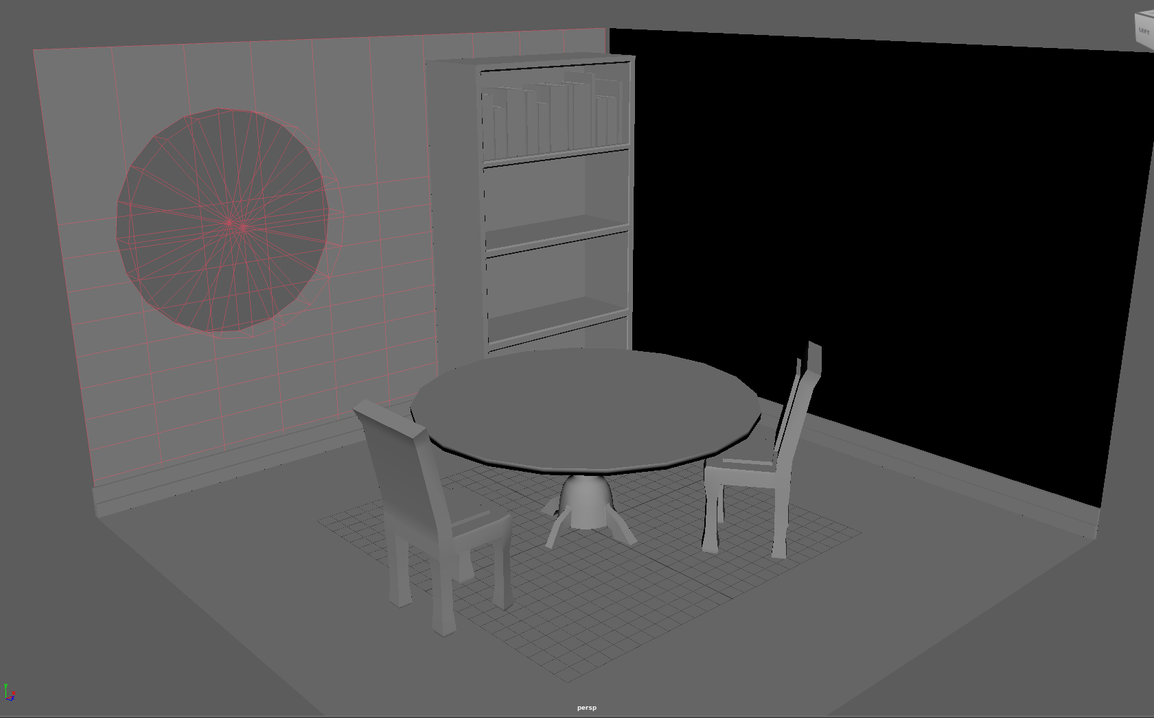
- Summary: This week was fun working with beveling and subtracting. Snapping things to the grid was also fun. Also figuring out subtracting to make that window. Copying and scaling the books was cool. And then using the edge loop tool to make the bookshelf. This week just was fun to experiment and figure out what I want my room to look like. And I did baseboards too. We’ll see what else we will add. Github was fixed this week for me, cause last week I had it on my One drive. Figuring out how to transfer that was fun.

